3.4 Overview of tests involving residuals, 3.5 Correlation test of normality, and 3.7 F test for lack of fit

Formal hypothesis tests can be done also to help with making decisions about the regression model satisfying its assumptions.

Read on your own. We will only discuss a couple of them.

3.6 Tests for constancy of error variance

Modified Levene’s (Brown-Forsythe) Test

The hypotheses can be written informally as

H₀: Constant variance
H_{a}: Non-constant variance

This test can be used when the error variance consistently increases or decreases as a function of X. The test still works even if the normality assumption of the ε_{i} is violated.

- Find the residuals from the sample regression model.
- Divide the data into two groups using the median of X. Denote the corresponding residuals as e_{i1} and e_{i2}.
- Find the median residual value, 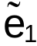 and 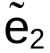, for both groups.
- Find the absolute deviation of the residuals about their median: d_{i1}=|e_{i1}-| and d_{i2}=|e_{i2}-|.
- Use the standard two-sample t-test for population means (pooled variance) to conduct the hypothesis test.
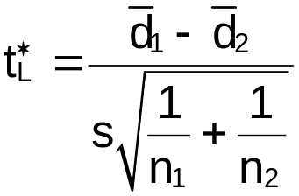

where
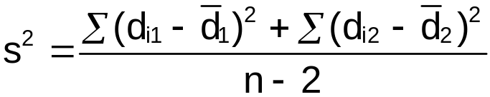
n₁=number of observations in group 1
n₂=number of observations in group 2
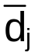=sample mean of d_{ij} for group j

This test statistic has approximately a t(n-2) distribution under the hypothesis of constant variance.

Note that the test statistic is measuring the average deviation from the residual median for each group. To understand the statistic, think about what would happen if the d_{i1}’s where much larger than the d_{i2}’s.

Example: College and HS GPA (HS_college_GPA_ch3.R)

> gpa<-read.table(file =
"C:\\chris\\UNL\\STAT870\\Chapter1\\gpa.txt",
header=TRUE, sep = "")
> mod.fit<-lm(formula = College.GPA ~ HS.GPA, data = gpa)

> library(car) #The Levene's Test function is in the
package for Fox and Weisberg's book
(although the function is not mentioned
in the book!)
> group<-ifelse(test = gpa$HS.GPA < median(gpa$HS.GPA),
yes = 1, no = 2)
> leveneTest(y = mod.fit$residuals, group = group)

Levene's Test for Homogeneity of Variance (center = median)
Df F value Pr(>F)
group 1 0.0766 0.7851
18
Warning message:
In leveneTest.default(y = mod.fit$residuals, group = group) :
group coerced to factor.

#Could use leveneTest(y = mod.fit$residuals, group =
# factor(group)) to avoid the warning message

Fox uses a regular ANOVA model to produce a F-statistic. Remember that a t-random variable squared with 18 degrees of freedom is an F-random variable with 1 numerator degree of freedom and 18 denominator degrees of freedom. Thus, the test statistic is . Below is some more code just to verify the leveneTest() function was doing what we want it to do.

> #Using the formulas instead for Levene's test
> e.tilde<-tapply(X = mod.fit$residuals, INDEX = group,
FUN = median)
> data.frame(gpa, e = mod.fit$residuals, group, med.e =
e.tilde[group]) #Show groups, e.tilde[group]
matches up residuals with
correct median
HS.GPA College.GPA e group med.e
1 3.04 3.1 0.26546091 2 0.09011976
2 2.35 2.3 -0.05177482 1 -0.07728677
3 2.70 3.0 0.40334475 2 0.09011976
4 2.05 1.9 -0.24187731 1 -0.07728677
5 2.83 2.5 -0.18761083 2 0.09011976
6 4.32 3.7 -0.03010181 2 0.09011976
7 3.39 3.4 0.32058048 2 0.09011976
8 2.32 2.6 0.26921493 1 -0.07728677
9 2.69 2.8 0.21034134 2 0.09011976
10 0.83 1.6 0.31170591 1 -0.07728677
11 2.39 2.0 -0.37976115 2 0.09011976
12 3.65 2.9 -0.36133070 2 0.09011976
13 1.85 2.3 0.29805437 1 -0.07728677
14 3.83 3.2 -0.18726921 2 0.09011976
15 1.22 1.8 0.23883914 1 -0.07728677
16 1.48 1.4 -0.34307203 1 -0.07728677
17 2.28 2.0 -0.30279873 1 -0.07728677
18 4.00 3.8 0.29378887 2 0.09011976
19 2.28 2.2 -0.10279873 1 -0.07728677
20 1.88 1.6 -0.42293538 1 -0.07728677

> d<-abs(mod.fit$residuals - e.tilde[group])
> t.test(formula = d ~ group, mu = 0, var.equal = TRUE,
alternative = "two.sided")

Two Sample t-test
data: d by group
t = -0.2768, df = 18, p-value = 0.7851
alternative hypothesis: true difference in means is not equal to 0
95 percent confidence interval:
-0.1375136 0.1055000
sample estimates:
mean in group 1 mean in group 2
0.2479522 0.2639590

The test statistic is and the p-value is 0.7851.

There is not sufficient evidence against the constant variance assumption.

Breusch-Pagan Test

Assumes the error terms are:
- Normally distributed (different from Levene)
- Variance of ε_{i}, denoted by 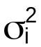, is related to X by  where “log” means natural log. This means that increases or decreases with X_{i} depending on the value of γ₁. Note that if γ₁=0, then we have constant variance!

Test H₀:γ₁=0 vs. H_{a}:γ₁≠0.

Test statistic: 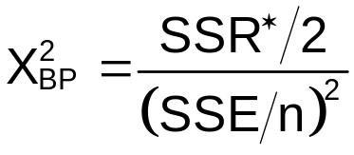
where

SSR∗ is the regression sum of squares when regressing e² on X and SSE is the usual sum of square error.

In large samples, this test statistic has approximately a χ² distribution with 1 degree of freedom.

Steps:
- For the regression model E(Y_{i})=β₀+β₁X_{i}, find the residuals and SSE.
- Using the squared residuals as the response variable and X as the independent variable, find SSR∗ for this model.
- Calculate the test statistic and p-value.

Example: College and HS GPA (HS_college_GPA_ch3.R)

> library(lmtest) #Location of the function
> bptest(formula = College.GPA ~ HS.GPA, data = gpa,
studentize = FALSE) #KNN version of the test

Breusch-Pagan test

data: College.GPA ~ HS.GPA
BP = 0.1959, df = 1, p-value = 0.658

 and p-value = 0.65805

There is not sufficient evidence against the constant variance assumption.

Example: Trees data from MASS package (trees.R)

> #Levene's test
> library(car)
> group<-ifelse(test = trees$Height <
median(trees$Height), yes = 1, no = 2)
> leveneTest(y = mod.fit$residuals, group =
factor(group))

Levene's Test for Homogeneity of Variance
Df F value Pr(>F)
group 1 6.761 0.01451 *
29

> # Breusch Pagan test
> library(lmtest)
> bptest(formula = Volume ~ Height, data = trees,
studentize = FALSE)

Breusch-Pagan test
data: Volume ~ Height
BP = 7.4901, df = 1, p-value = 0.006204

> #Do same tests for transformed Y
> leveneTest(y = mod.fit2$residuals, group = group)

Levene's Test for Homogeneity of Variance
Df F value Pr(>F)
group 1 0.1017 0.7521
29

> bptest(formula = Volume^lambda.hat ~ Height, data =
trees, studentize = FALSE)

Breusch-Pagan test
data: Volume^lambda.hat ~ Height
BP = 0.4716, df = 1, p-value = 0.4923

> leveneTest(y = mod.fit3$residuals, group = group)

Levene's Test for Homogeneity of Variance
Df F value Pr(>F)
group 1 1.1011 0.3027
29

> bptest(formula = log(Volume) ~ Height, data = trees,
studentize = FALSE)

Breusch-Pagan test

data: log(Volume) ~ Height
BP = 0.4757, df = 1, p-value = 0.4904

As expected, the tests reject constant variance before doing the transformation on Y. After the transformation, they do not reject constant variance.

